Jan Derlatka, 86, JN, Info (Team Leader)

Lucca Pereira Martins, 86, JN, Info

Maya Roy Prabhakaran, 99, M, Mech

Jenny Hardwick, 99, M, Mech

Szymon Piatek, 110, PEM, Elec

Noah Barker, 110, PEM, Elec

[Name, Lab Group, College, Sub-team]

*TEam 4 IDP L1*

Team Name: Porous a Drink

Robot Name: Wall-E 2.0

# Approach:

We have opted for a general, works for all approach, where we account for all possibilities of where the cube could be by sweeping all possible positions, removing the need for cube detection. To collect the cubes, we aim to use two large arms which will open when sweeping, drive the car forwards to a maximum value, and close around the cube, but not squeeze it. At this point we will measure porosity, either by using infrared sensors to measure along the cube, or a combination of infrared sensors with a mechanical force input. The car will reverse over the ramp and drag the cube behind it, ensuring the cube isn’t lost by using arms of similar height to it. When depositing the cube back, we aim to turn the car 90 degrees on the spot and put down the first cube deeper in the box, or alternatively manoeuvrer into the box.

## Moving

Keeping robot movement as simple and fundamental as possible, and minimising or completely removing the number of turns it must make, will ensure an accurate and robust result. If the robot can remain on the white line for the duration of the exercise, this removes one of the largest uncertainties in the task: the robot losing its positioning.

We will opt for 2 fixed, rear wheels connected to a motor and explore the possibility of 2 ball rollers at the front of the vehicle. This would allow us to turn on the spot when delivering the cubes, but also micro adjust to ensure the robot stays on the central white line. The rear wheels would generate sufficient torque to cross the ramp both forwards and in reverse.

The argument against 4 wheels, whether fixed or rotational, was that the requirement for an additional motor would increase the complexity and the weight of the robot, whereas the ball rollers would provide more flexibility in terms of motion and micro adjustments.

## Arms

As mentioned above, the cubes will be collected by two wide arms in a pincer motion, sweeping a wide arc which covers all possible cube positions (ref fig1). If the cube is towards the start of the possible locations, the robot will gently push the cube forward, and once the arms are closed and it starts reversing, the cube will be securely dragged behind it, not squeezed (ref fig2).

We decided on this approach to entirely remove the need for cube detection, which would have been one of the most complicated steps when finding the third cube. The main risk is knocking other cubes out of place, but careful and gentle arm movements will ensure this is not a problem. When reversing over the ramp, if necessary, the arms will raise a small amount to provide clearance and prevent them from interfering with movement.

Figure 2 Pincer Mechanism for Arms

Figure Sweeping Arcs for Each Cube

## Determining Cube Porosity

Figure 4 Method 2

Figure 5 Method 3

Figure 3 Method 1

There are 3 main options in consideration for cube identification:

1. The combined use of an infrared sensor and a mechanical input from a lever arm, squeezing the cube against the floor each time with an equal amount of force, and then measuring distance from the arm to the floor (ref fig3). If the cube is less dense, then the arm would move further into it, and hence significantly closer to the floor than a denser cube. The disadvantages include the need for another arm, and hence another connection to the motor, and the dependency on sensor sensitivity. If the force applied is gradual but small, the difference in sensor readings may be insufficient to differentiate between the cubes, and increasing the force applied would be more complex. This is the most promising option and the one we will investigate first.
2. Use of an infrared sensor taking multiple readings through the cube as the robot drives past it, then determining an average measurement. You would expect a denser cube to have a lower average infrared reading. To keep this a fair test, the cube would have to be at the same position each time (ref fig4), which may be a challenge given our collecting approach
3. Similarly to option one, applying a horizontal compression force and using a distance sensor (possibly made with an infrared sensor), we can apply a gradual force and record when the cube interferes with the sensor, which would be dependent on the materials Poisson ratio (ref fig5).

## Depositing into Box

Figure 7 Method 3

Figure 6 Method 2

Likewise, there are 3 main options for delivering the cube, all of which would be done with coding rather than sensors etc.

1. Rotating the car on the spot; this would be possible with the use of ball rollers given they can generate sufficient force to rotate the back wheels on the spot. The robot would reverse up to the intersection then rotate and deposit the cubes, before reversing back to the intersection and reacquiring the central white line. This minimises how much the car moves away from the line.
2. A similar alternative would be to reverse the car further back towards the start, then allow it to turn in a wider arc into the box. This would be a smoother motion and remove any ‘jittering’ which may arise from turning on the spot but would deviate more from the white line than option 1. (ref fig6).
3. Rotating the arms and allowing the robot to stay on the line. If the arms were long enough, then one arm could be opened and the other used to gently push the cube into the box (ref fig7). However, this option was discarded because increasing the length of the arms further would be unreasonable, and the risk of knocking other cubes out of position is high.

## Following the line

We aim to use four line sensors, two at the front and two at the back, all of which would rest on the white line and would provide the main steering for the robot. If any of the sensors detect black, the robot would readjust accordingly. When leaving the line to deposit the cubes, the sensors would not be considered, ‘deactivated’ so to speak, and the motion would be programmed.

# Implementation:

Fig8 shows how we aim to integrate the three teams, with orange representing mechanical, white: information, and blue: electrical.

Figure 8 Sub-team Integration

## A picture containing indoor Description automatically generatedDiagram, engineering drawing Description automatically generatedDiagram Description automatically generatedMechanical

Figure 9 Concept Design of Robot with dimensions

Having consider a rough, feasible design to start from (ref fig9), we decided on the best option of materials for each part:

* Chassis – MDF, lightweight and strong, it would provide enough rigidity to support all the components whilst being lighter than metal alternatives.
* Motor mounts – Aluminium, similarly to MDF, is also lightweight and strong, but also versatile and easily machined into the required component.
* Fastenings – mostly M3 screws

Construction methods would include laser cutting and hand making, with the focus being on easy assembling and disassembling of components in case they need to be changed, fixed, replaced etc.

## Electrical

Figure 10 Electrical Components Block Diagram

**Information

Figure 11 Exploration & Navigation Algorithms

The overall approach is simple and robust, removing the need for exploration and simplifying navigation to the core movements: forwards, backwards and turning. The use of the line sensors will ensure the robot stays on track, should it even deviate in the first place.

# Risks:

**[RISK, LIKELIHOOD, MINIMISING]**

|  |  |  |
| --- | --- | --- |
| **Risk** | **Likelihood**  **(1:least -5:most)** | **Risk Reduction** |
| Failing to collect cube or slipping out in transit | **1** | Ensure arms sweep the entire area gently and arms are similar height to cube |
| Knocking into other cubes | **3** | Best avoided through trial and error, with careful consideration of all possibilities |
| Failing to cross ramp | **5** | Adjustments have been considered should this happen, ie. raising arms |
| Failing to determine porosity | **4** | Ensure sensors are accurate and well-placed, and code is robust at evaluating |
| Losing track of white line | **2** | Sufficient testing and robust code to ensure adjustments are smooth & correct |

# Project Management:

## Gantt Chart

The Gantt Chart will help keep all team members on track and aware of upcoming deadlines. Keeping it updated through the project and overestimate the length of task will ensure punctuality by good time management (ref Chart 1).

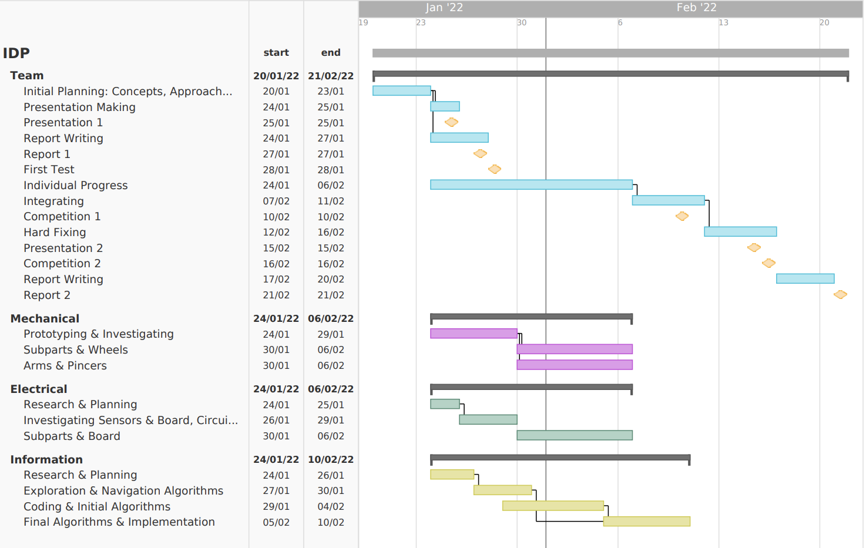

Chart 1 Gantt Chart

## GitHub Repository

Using a single repository to share and store all files such as code, CAD models, sketches and graphs, will simplify distribution and version control across teams, maximising coordination and communication.